**[next →](https://www.javatpoint.com/java-jbutton)**[**← prev**](https://www.javatpoint.com/java-close-awt-window)

**Java Swing Tutorial**

**Java Swing tutorial** is a part of Java Foundation Classes (JFC) that is *used to create window-based applications*. It is built on the top of AWT (Abstract Windowing Toolkit) API and entirely written in java.

Unlike AWT, Java Swing provides platform-independent and lightweight components.

The javax.swing package provides classes for java swing API such as JButton, JTextField, JTextArea, JRadioButton, JCheckbox, JMenu, JColorChooser etc

First Java Program ……

1

import javax.swing.*;

class Swing1

{

public static void main(String args[])

{

JFrame frame=new JFrame();

frame.setVisible(true);

frame.setDefaultCloseOperation(JFrame.EXIT_ON_CLOSE);

//this line is used for terminate the close option and use on cmd

}

}

Swing1.JPG

2

import javax.swing.*;

class Swing2

{

public static void main(String args[])

{

JFrame frame=new JFrame();

frame.setVisible(true);

frame.setDefaultCloseOperation(JFrame.EXIT_ON_CLOSE);

frame.setSize(700,400);

frame.setLocation(100,200);

//fframe.setBounds(100,500,700,400);

}

}

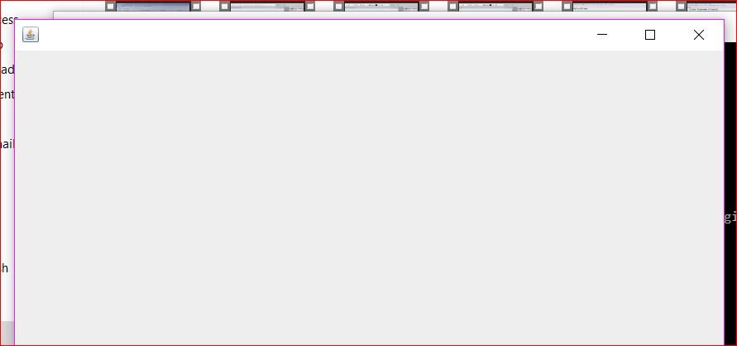

3

import javax.swing.*;

class Swing3

{

public static void main(String args[])

{

JFrame frame=new JFrame();

frame.setVisible(true);

frame.setDefaultCloseOperation(JFrame.EXIT_ON_CLOSE);

//frame.setSize(700,400);

//frame.setLocation(100,200);

frame.setBounds(100,200,700,400);

ImageIcon ic=new ImageIcon("Aa.png");

frame.setIconImage(ic.getImage());

frame.setTitle("Abhi Frame");

}

}

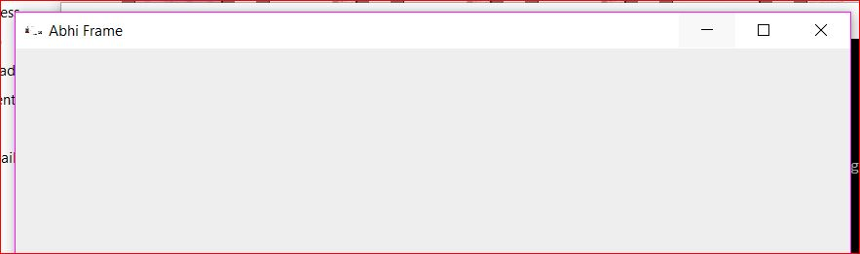

4

import javax.swing.*;

import java.awt.*;

class Swing4

{

public static void main(String args[])

{

JFrame frame=new JFrame();

frame.setVisible(true);

frame.setLayout(null);

frame.setDefaultCloseOperation(JFrame.EXIT_ON_CLOSE);

//frame.setSize(700,400);

//frame.setLocation(100,200);

frame.setBounds(100,200,700,400);

ImageIcon ic=new ImageIcon("Aa.jpg");

frame.setIconImage(ic.getImage());

frame.setTitle("Abhi Frame");

frame.setBackground(Color.RED);

}

}

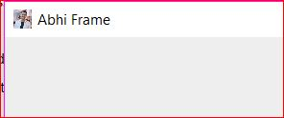

5

import javax.swing.*;

import java.awt.*;

import java.awt.event.*;

class Test

{

public static void main(String args[])

{

JFrame frame=new JFrame();

frame.setDefaultCloseOPeration(JFrame.EXIT_ON_CLOSE);

Container c=frame.getContentPane();

frame.setVisible(true);

c.setLayout(null);

c.setBounds(100,100,700,500);

JTextField txt = new JTextField();

c.add(txt);

}

}

6

import javax.swing.*;

import java.awt.*;

class TotalDemo

{

public static void main(String args[])

{

JFrame frame=new JFrame();

frame.setVisible(true);

frame.setDefaultCloseOperation(JFrame.EXIT_ON_CLOSE);

frame.setBounds(100,100,600,400);

Container c=frame.getContentPane();

c.setLayout(null);

c.setVisible(true);

c.setBackground(Color.YELLOW);

Font f = new Font("Arial",Font.BOLD,15);

JLabel l1=new JLabel("USER Name");

l1.setBounds(50,100,100,50);

l1.setFont(f);

JTextField text=new JTextField("Name");

text.setBounds(200,100,100,30);

JLabel l2=new JLabel("Password");

l2.setBounds(50,170,100,50);

l2.setFont(f);

JPasswordField pass=new JPasswordField();

pass.setBounds(200,170,100,30);

c.add(l1);

c.add(text);

c.add(l2);

c.add(pass);

}

}

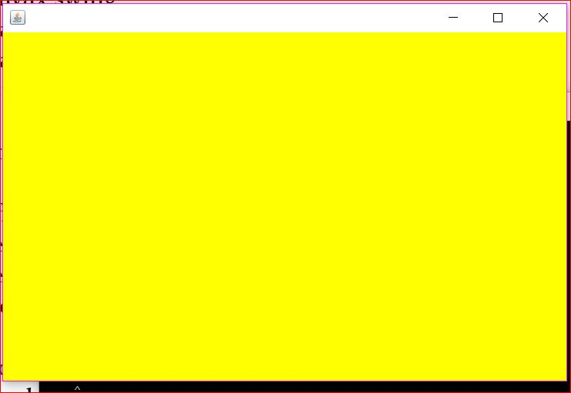

# Java JRadioButton

The JRadioButton class is used to create a radio button. It is used to choose one option from multiple options. It is widely used in exam systems or quiz.

It should be added in ButtonGroup to select one radio button only.

1. **import** javax.swing.*;
2. **import** java.awt.event.*;
3. **class** RadioButtonExample **extends** JFrame **implements** ActionListener{
4. JRadioButton rb1,rb2;
5. JButton b;
6. RadioButtonExample(){
7. rb1=**new** JRadioButton("Male");
8. rb1.setBounds(100,50,100,30);
9. rb2=**new** JRadioButton("Female");
10. rb2.setBounds(100,100,100,30);
11. ButtonGroup bg=**new** ButtonGroup();
12. bg.add(rb1);bg.add(rb2);
13. b=**new** JButton("click");
14. b.setBounds(100,150,80,30);
15. b.addActionListener(**this**);
16. add(rb1);add(rb2);add(b);
17. setSize(300,300);
18. setLayout(**null**);
19. setVisible(**true**);
20. }
21. **public** **void** actionPerformed(ActionEvent e){
22. **if**(rb1.isSelected()){
23. JOptionPane.showMessageDialog(**this**,"You are Male.");
24. }
25. **if**(rb2.isSelected()){
26. JOptionPane.showMessageDialog(**this**,"You are Female.");
27. }
28. }
29. **public** **static** **void** main(String args[]){
30. **new** RadioButtonExample();
31. }}

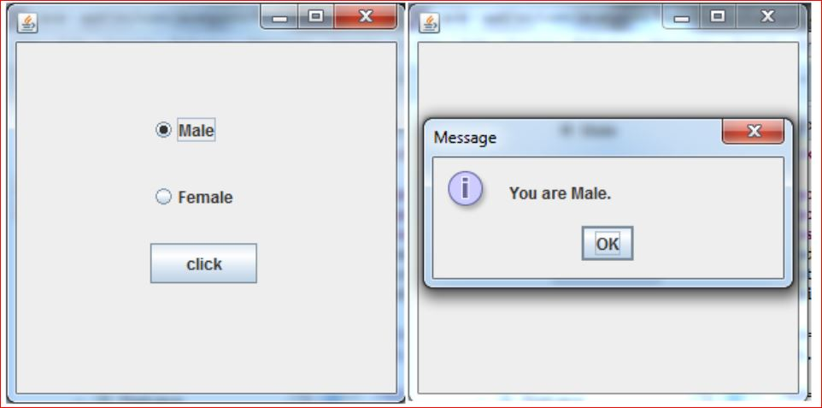

import javax.swing.*;

import java.awt.*;

class RadioDemo

{

public static void main(String args[])

{

JFrame frame=new JFrame("RAdio BAsic Concept");

frame.setVisible(true);

frame.setBounds(100,100,700,500);

frame.setDefaultCloseOperation(JFrame.EXIT_ON_CLOSE);

Container c=frame.getContentPane();

c.setBackground(Color.YELLOW);

c.setLayout(null);

JRadioButton male=new JRadioButton("MALE");

male.setBounds(50,100,100,50);

JRadioButton female=new JRadioButton("FEMALE");

female.setBounds(200,100,100,50);

JRadioButton gen=new JRadioButton("GEN");

gen.setBounds(50,160,100,50);

JRadioButton obc=new JRadioButton("OBC");

obc.setBounds(200,160,100,50);

ButtonGroup gender=new ButtonGroup();

gender.add(male);

gender.add(female);

female.setSelected(true);

//how to use Multiple ButtonGroup in a single programe

ButtonGroup cast=new ButtonGroup();

cast.add(gen);

cast.add(obc);

gen.setSelected(true);

c.add(male);

c.add(female);

c.add(gen);

c.add(obc);

}

}

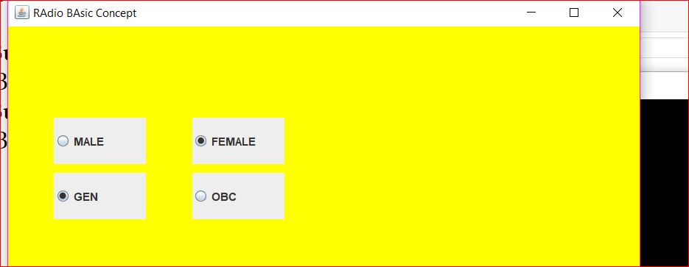

import javax.swing.*;

import java.awt.*;

class MyCombo

{

public static void main(String args[])

{

JFrame frame=new JFrame("MY COMBO BOX");

frame.setVisible(true);

frame.setDefaultCloseOperation(JFrame.EXIT_ON_CLOSE);

frame.setBounds(200,100,600,400);

Container cntr=frame.getContentPane();

cntr.setLayout(null);

String[] arr={"A","B","C","D"} ;

JComboBox jcb=new JComboBox(arr);

jcb.setBounds(100,100,100,30);

jcb.setEditable(true);//for edit the combobox

//for select the item enternally

jcb.setSelectedIndex(3);

jcb.setSelectedItem("D");

//Above two ,ethods are used to select the item in combobox

//how to set font in jcombobox

Font f=new Font("Constantia",Font.BOLD,15);

jcb.setFont(f);

//how to check a whoch index is selected of a JCOMBOBBOX

cntr.add(jcb);

cntr.revalidate();//for can not resize the frame due to some effect

}

}

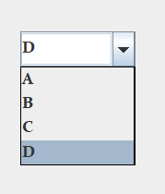

import javax.swing.*;

import java.awt.*;

import java.awt.event.*;

class MyCombo1

{

static Container cntr;

static JComboBox jcb;

static Font f;

static JLabel lb;

static JLabel lbb;

public static void main(String args[])

{

JFrame frame=new JFrame("MY COMBO BOX");

frame.setVisible(true);

frame.setDefaultCloseOperation(JFrame.EXIT_ON_CLOSE);

frame.setBounds(200,100,600,400);

cntr=frame.getContentPane();

cntr.setLayout(null);

String[] arr={"A","B","C","D"} ;

jcb=new JComboBox(arr);

jcb.setBounds(100,100,100,30);

//for add Item in JcomboBox

jcb.addItem("E");

jcb.addItem("F");

//for remove Item in JcomboBox

jcb.removeItem("A");

jcb.removeItem("B");

JButton btn=new JButton("SUBMIT");

btn.setBounds(300,100,100,40);

lb=new JLabel("msg");

lb.setBounds(200,200,100,40);

lbb=new JLabel("msg");

lbb.setBounds(350,200,100,40);

jcb.setEditable(true);//for edit the combobox

//for select the item enternally

jcb.setSelectedIndex(3);

jcb.setSelectedItem("D");

//Above two methods are used to select the item in combobox

//how to set font in jcombobox

f=new Font("Constantia",Font.BOLD,15);

jcb.setFont(f);

//how to check a whoch index is selected of a JCOMBOBBOX

cntr.add(jcb);

cntr.add(btn);

cntr.add(lb);

cntr.add(lbb);

cntr.revalidate();//for can not resize the frame due to some effect

btn.addActionListener(new ActionPre());

}

static class ActionPre implements ActionListener

{

public void actionPerformed(ActionEvent ae)

{

cntr.setBackground(Color.YELLOW);

lb.setText(Integer.toString(jcb.getSelectedIndex()));

//FOR SEELCT THE VALUE FROM COMBO BOX

String item=(String)jcb.getSelectedItem();

lbb.setText(item);

}

}

}

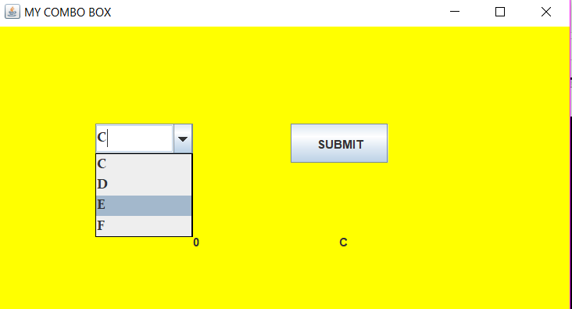

//this is a norml program of swing in which Actioon listener performend

import javax.swing.*;

import java.awt.*;

import java.awt.event.*;

class MyFrame extends JFrame implements ActionListener

{

JButton btn1=new JButton("RED");

JButton btn2=new JButton("YELLOW");

JButton btn3=new JButton("ORANGE");

Container c;

MyFrame()

{

c=this.getContentPane();

c.setBackground(Color.RED);

c.setLayout(null);

btn1.setBounds(100,100,100,50);

btn2.setBounds(250,100,100,50);

btn3.setBounds(400,100,100,50);

btn1.addActionListener(this);

btn2.addActionListener(this);

btn3.addActionListener(this);

c.add(btn1);

c.add(btn2);

c.add(btn3);

}

public void actionPerformed(ActionEvent ae)

{

if(ae.getSource()==btn1)

{

c.setBackground(Color.RED);

}

if(ae.getSource()==btn2)

{

c.setBackground(Color.YELLOW);

}

if(ae.getSource()==btn3)

{

c.setBackground(Color.ORANGE);

}

}

}

class Action

{

public static void main(String args[])

{

MyFrame f=new MyFrame();

f.setVisible(true);

f.setLayout(null);

f.setDefaultCloseOperation(JFrame.EXIT_ON_CLOSE);

f.setBounds(100,100,700,500);

}

}

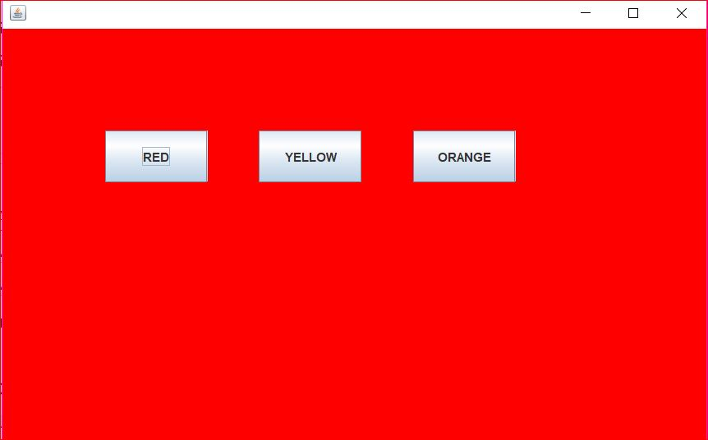

import javax.swing.*;

import java.awt.*;

import java.awt.event.*;

class ActionDemo2

{

static Container c;

public static void main(String args[])

{

JFrame frame=new JFrame("Action Demo using Seperate class");

frame.setVisible(true);

frame.setDefaultCloseOperation(JFrame.EXIT_ON_CLOSE);

frame.setBounds(200,100,700,500);

c=frame.getContentPane();

c.setLayout(null);

c.setBackground(Color.YELLOW);

JButton red=new JButton("RED");

red.setBounds(100,50,100,50);

JButton yellow=new JButton("YELLOW");

yellow.setBounds(250,50,100,50);

c.add(red);

red.addActionListener(new ActionRed());

c.add(yellow);

yellow.addActionListener(new ActionYellow());

}

}

class ActionRed implements ActionListener

{

public void actionPerformed(ActionEvent ae)

{

ActionDemo2.c.setBackground(Color.GREEN);

}

}

class ActionYellow implements ActionListener

{

public void actionPerformed(ActionEvent ae)

{

ActionDemo2.c.setBackground(Color.YELLOW);

}

}

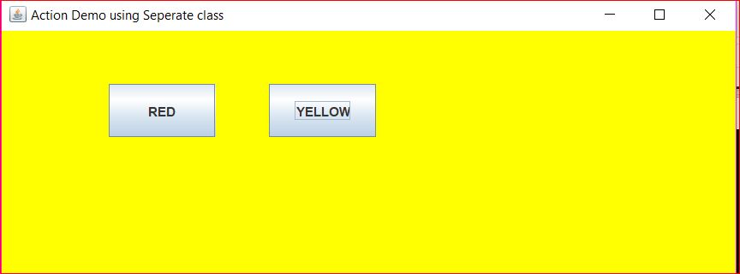

import javax.swing.*;

import java.awt.*;

import java.awt.event.*;

class ActionDemo3

{

static Container c;

public static void main(String args[])

{

JFrame frame=new JFrame("Action Demo using Seperate class");

frame.setVisible(true);

frame.setDefaultCloseOperation(JFrame.EXIT_ON_CLOSE);

frame.setBounds(200,100,700,500);

c=frame.getContentPane();

c.setLayout(null);

c.setBackground(Color.YELLOW);

JButton red=new JButton("RED");

red.setBounds(100,50,100,50);

JButton yellow=new JButton("YELLOW");

yellow.setBounds(250,50,100,50);

c.add(red);

c.add(yellow);

ActionPre obj=new ActionPre();

yellow.addActionListener(obj);

red.addActionListener(obj);

}

}

class ActionPre implements ActionListener

{

public void actionPerformed(ActionEvent ae)

{

if(ae.getSource()==red)

{

ActionDemo3.c.setBackground(Color.RED);

}

if(ae.getSource()==yellow)

{

ActionDemo3.c.setBackground(Color.GREEN);

}

}

}

import javax.swing.*;

import java.awt.*;

class RegDemo

{

public static void main(String args[])

{

JFrame frame=new JFrame("Regestration form Demo");

frame.setVisible(true);

frame.setDefaultCloseOperation(JFrame.EXIT_ON_CLOSE);

frame.setBounds(200,100,740,500);

Container cntr=frame.getContentPane();

cntr.setLayout(null);

cntr.setBackground(Color.YELLOW);

JLabel name_label=new JLabel("Name");

name_label.setBounds(50,50,60,30);

JTextField name_tf=new JTextField();

name_tf.setBounds(150,50,150,25);

JLabel mobile_label=new JLabel("Mobile");

mobile_label.setBounds(50,100,60,30);

JTextField mobile_tf=new JTextField();

mobile_tf.setBounds(150,100,150,25);

JLabel dob_label=new JLabel("DOB");

dob_label.setBounds(50,150,60,30);

String[] day_arr=new String[31];

for(int i=1;i<=31;i++)

day_arr[i-1]=Integer.toString(i);

JComboBox day=new JComboBox(day_arr);

day.setBounds(150,150,50,25);

String[] month_arr={"JAN","FEB","MAR","APR","MAY","JUNE","JLY","AUG","SEP","OCT","NOV","DEC"};

JComboBox month=new JComboBox(month_arr);

month.setBounds(220,150,70,25);

String[] year_arr=new String[70];

for(int i=1951;i<=2020;i++)

year_arr[i-1951]=Integer.toString(i);

JComboBox year=new JComboBox(year_arr);

year.setBounds(310,150,60,25);

JLabel gender_label=new JLabel("GENDER");

gender_label.setBounds(50,200,60,30);

JRadioButton male=new JRadioButton("MALE");

male.setBounds(150,200, 80,30);

JRadioButton female=new JRadioButton("FEMALE");

female.setBounds(280,200,80,30);

ButtonGroup gender=new ButtonGroup();

gender.add(male);

gender.add(female);

JLabel address_label=new JLabel("ADDRESS");

address_label.setBounds(50,250,60,30);

JTextArea add_ta=new JTextArea();

add_ta.setBounds(150,250,230,50);

JCheckBox tandc=new JCheckBox("I accept all terms and conditions");

tandc.setBounds(50,320,250,25);

JButton submit=new JButton("SUBMIT");

submit.setBounds(199,355,100,40);

JTextArea output=new JTextArea();

output.setBounds(400,50,300,350);

cntr.add(name_label);

cntr.add(name_tf);

cntr.add(mobile_label);

cntr.add(mobile_tf);

cntr.add(dob_label);

cntr.add(day);

cntr.add(month);

cntr.add(year);

cntr.add(gender_label);

cntr.add(male);

cntr.add(female);

cntr.add(address_label);

cntr.add(add_ta);

cntr.add(tandc);

cntr.add(submit);

cntr.add(output);

}

}

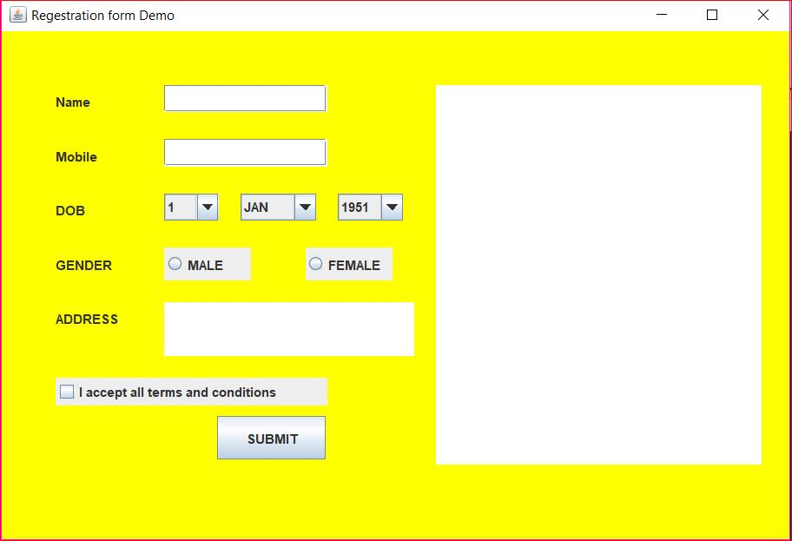

import javax.swing.*;

import java.awt.*;

import java.awt.event.*;

class ActionRegDemo

{

static JLabel name_label;

static JTextField name_tf;

static JLabel mobile_label;

static JTextField mobile_tf;

static JLabel dob_label;

static JComboBox day;

static JComboBox month;

static JComboBox year;

static JLabel gender_label;

static JRadioButton male;

static JRadioButton female;

static JTextArea add_ta;

static JCheckBox tandc;

static JButton submit;

static JTextArea output;

public static void main(String args[])

{

JFrame frame=new JFrame("First Demo Software");

frame.setVisible(true);

frame.setDefaultCloseOperation(JFrame.EXIT_ON_CLOSE);

frame.setBounds(200,100,740,500);

ImageIcon ic=new ImageIcon("Aa.jpg");

frame.setIconImage(ic.getImage());

Container cntr=frame.getContentPane();

cntr.setLayout(null);

cntr.setBackground(Color.YELLOW);

name_label=new JLabel("Name");

name_label.setBounds(50,50,60,30);

name_tf=new JTextField();

name_tf.setBounds(150,50,150,25);

mobile_label=new JLabel("Mobile");

mobile_label.setBounds(50,100,60,30);

mobile_tf=new JTextField();

mobile_tf.setBounds(150,100,150,25);

dob_label=new JLabel("DOB");

dob_label.setBounds(50,150,60,30);

String[] day_arr=new String[31];

for(int i=1;i<=31;i++)

day_arr[i-1]=Integer.toString(i);

day=new JComboBox(day_arr);

day.setBounds(150,150,50,25);

String[] month_arr={"JAN","FEB","MAR","APR","MAY","JUNE","JLY","AUG","SEP","OCT","NOV","DEC"};

month=new JComboBox(month_arr);

month.setBounds(220,150,70,25);

String[] year_arr=new String[70];

for(int i=1951;i<=2020;i++)

year_arr[i-1951]=Integer.toString(i);

year=new JComboBox(year_arr);

year.setBounds(310,150,60,25);

gender_label=new JLabel("GENDER");

gender_label.setBounds(50,200,60,30);

male=new JRadioButton("MALE");

male.setBounds(150,200, 80,30);

female=new JRadioButton("FEMALE");

female.setBounds(280,200,80,30);

ButtonGroup gender=new ButtonGroup();

gender.add(male);

gender.add(female);

JLabel address_label=new JLabel("ADDRESS");

address_label.setBounds(50,250,60,30);

add_ta=new JTextArea();

add_ta.setBounds(150,250,230,50);

tandc=new JCheckBox("I accept all terms and conditions");

tandc.setBounds(50,320,250,25);

submit=new JButton("SUBMIT");

submit.setBounds(199,355,100,40);

//anonymaous inner class

submit.addActionListener(new ActionListener()

{

public void actionPerformed(ActionEvent event)

{

submit_action(event);

}

});

output=new JTextArea();

output.setBounds(400,50,300,350);

cntr.add(name_label);

cntr.add(name_tf);

cntr.add(mobile_label);

cntr.add(mobile_tf);

cntr.add(dob_label);

cntr.add(day);

cntr.add(month);

cntr.add(year);

cntr.add(gender_label);

cntr.add(male);

cntr.add(female);

cntr.add(address_label);

cntr.add(add_ta);

cntr.add(tandc);

cntr.add(submit);

cntr.add(output);

}

public static void submit_action(ActionEvent event)

{

if(tandc.isSelected()==true)

{

String name=name_tf.getText();

String mobile=mobile_tf.getText();

String day_name=(String)day.getSelectedItem();

String month_name=(String)month.getSelectedItem();

String year_name=(String)year.getSelectedItem();

String gen="Male";

if(female.isSelected())

gen="Female";

String address=add_ta.getText();

output.setText("Name\t "+name+"\nMobile"+mobile+"\nDOB\t"+day_name+" "+month_name+" "+year_name+

"\nGender\t"+gen+

"\nAddress \t" + address

);

}

else

{

output.setText("Please accept terms and conditions");

}

}

}

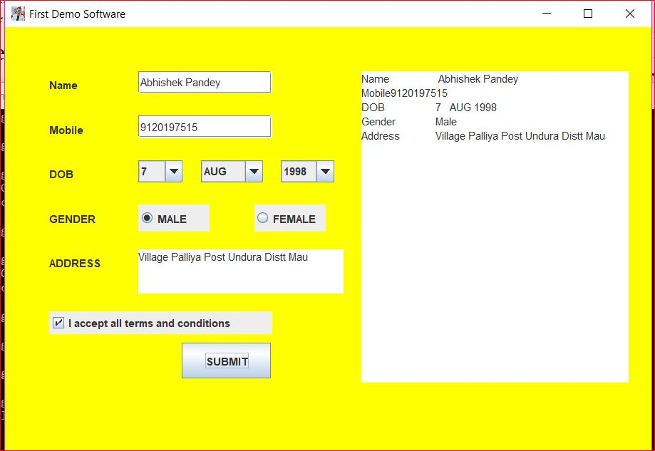

import javax.swing.*;

import java.awt.*;

import java.awt.event.*;

class Calci

{

static JLabel num1=new JLabel("NUMBER1");

static JLabel num2=new JLabel("NUMBER2");

static JTextField num1_tf=new JTextField();

static JTextField num2_tf=new JTextField();

static JButton add=new JButton("ADD");

static JButton subtract=new JButton("SUB");

static JButton multiply=new JButton("MULTI");

static JButton divide=new JButton("DIV");

static JLabel ans=new JLabel("Answer :");

static JTextField ans_tf=new JTextField();

static JLabel msg=new JLabel("Msg");

static JLabel ownrmsg=new JLabel("A normal and demo Application");

public static void main(String args[])

{

JFrame frame=new JFrame("Calculator for personal use");

frame.setVisible(true);

frame.setDefaultCloseOperation(JFrame.EXIT_ON_CLOSE);

frame.setBounds(200,100,500,500);

Container cntr=frame.getContentPane();

cntr.setLayout(null);

num1.setBounds(50,50,100,25);

num2.setBounds(50,90,100,25);

num1_tf.setBounds(130,50,100,25);

num2_tf.setBounds(130,90,100,25);

add.setBounds(20,130,80,30);

subtract.setBounds(110,130,80,30);

multiply.setBounds(200,130,80,30);

divide.setBounds(290,130,80,30);

ans.setBounds(50,180,200,25);

ans_tf.setBounds(130,180,200,25);

msg.setBounds(50,215,300,25);

ownrmsg.setBounds(50,300,500,70);

Font f=new Font("Constantia",Font.BOLD,15);

num1.setFont(f);

num2.setFont(f);

num1_tf.setFont(f);

num2_tf.setFont(f);

add.setFont(f);

subtract.setFont(f);

multiply.setFont(f);

divide.setFont(f);

ans.setFont(f);

ans_tf.setFont(f);

msg.setFont(f);

ownrmsg.setFont(f);

add.addActionListener(new ActionListener(){

public void actionPerformed(ActionEvent event)

{

add_action(event);

}

});

subtract.addActionListener(new ActionListener(){

public void actionPerformed(ActionEvent event)

{

subtract_action(event);

}

});

multiply.addActionListener(new ActionListener(){

public void actionPerformed(ActionEvent event)

{

multiply_action(event);

}

});

divide.addActionListener(new ActionListener(){

public void actionPerformed(ActionEvent event)

{

divide_action(event);

}

});

cntr.add(num1);

cntr.add(num2);

cntr.add(num1_tf);

cntr.add(num2_tf);

cntr.add(add);

cntr.add(subtract);

cntr.add(multiply);

cntr.add(divide);

cntr.add(ans);

cntr.add(ans_tf);

cntr.add(msg);

cntr.add(ownrmsg);

cntr.setBackground(Color.YELLOW);

}

public static void add_action(ActionEvent event)

{

String s1=num1_tf.getText();

String s2=num2_tf.getText();

float n1=0;

float n2=0;

try

{

n1=Float.parseFloat(s1);

n2=Float.parseFloat(s2);

//Float is a wrapper classs that belongs from java.lang package

}

catch(Exception ex)

{

msg.setText("Please enter a valid numaber");

}

float an=n1+n2;

String ans_str=Float.toString(an);

//float to string conversion

ans_tf.setText(ans_str);

}

public static void subtract_action(ActionEvent event)

{

String s1=num1_tf.getText();

String s2=num2_tf.getText();

float n1=0;

float n2=0;

try

{

n1=Float.parseFloat(s1);

n2=Float.parseFloat(s2);

//Float is a wrapper classs that belongs from java.lang package

}

catch(Exception ex)

{

msg.setText("Please enter a valid numaber");

}

float an=n1-n2;

String ans_str=Float.toString(an);

//float to string conversion

ans_tf.setText(ans_str);

}

public static void multiply_action(ActionEvent event)

{

String s1=num1_tf.getText();

String s2=num2_tf.getText();

float n1=0;

float n2=0;

try

{

n1=Float.parseFloat(s1);

n2=Float.parseFloat(s2);

//Float is a wrapper classs that belongs from java.lang package

}

catch(Exception ex)

{

msg.setText("Please enter a valid numaber");

}

float an=n1*n2;

String ans_str=Float.toString(an);

//float to string conversion

ans_tf.setText(ans_str);

}

public static void divide_action(ActionEvent event)

{

String s1=num1_tf.getText();

String s2=num2_tf.getText();

float n1=0;

float n2=0;

try

{

n1=Float.parseFloat(s1);

n2=Float.parseFloat(s2);

//Float is a wrapper classs that belongs from java.lang package

}

catch(Exception ex)

{

msg.setText("Please enter a valid numaber");

}

float an=n1/n2;

String ans_str=Float.toString(an);

//float to string conversion

ans_tf.setText(ans_str);

}

}

